Background chapters

Kinect Specifications

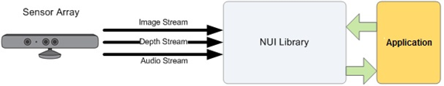lor image frames from the RGB camera, depth image frames from the depth

camera, and audio data from the microphone array to the SDK.

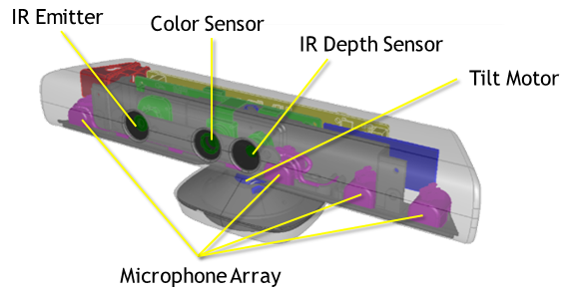

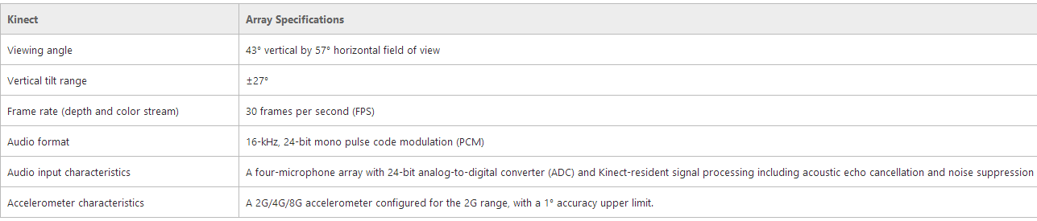

The Kinect for Windows Sensor contains a 3-axis accelerometer configured for a 2g range, where g is the acceleration due to gravity.

This allows the sensor to report its current orientation with respect to gravity.

Accelerometer data can help detect when the sensor is in an unusual orientation. It can also be used along with the floor plane data calculated by the SDK to provide more accurate 3-D projections in augmented reality scenarios.

The accelerometer has a lower limit of 1 degree accuracy. In addition, the accuracy is slightly temperature sensitive, with up to 3 degrees of drift over the normal operating temperature range. This drift can be p

Data Streams

Depth  
Depth data in mm.  
Max resolution is 640x480

Infrared Stream  
The depth sensor generates invisible IR light to determine an object's depth (distance) from the sensor. The primary use for the IR stream is to improve external camera calibration using a test pattern observed from both the RGB and IR camera to more accurately determine how to map coordinates from one camera space to another. You can also use IR data to capture an IR image in darkness as long as you provide your own IR source.

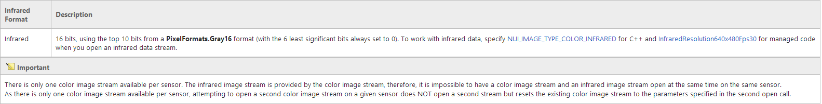

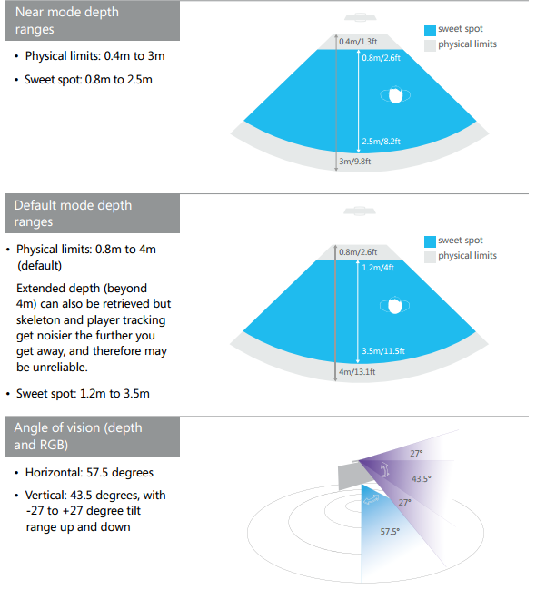

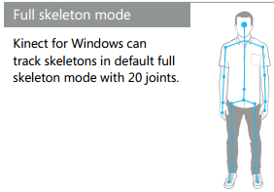

■ 640 × 480 at 30 frames per second (FPS) using red, green, and blue (RGB) for

1280 × 960 at 12 FPS using RGB format

Skeleton Tracking

The NUI API uses the depth stream to detect the presence of humans in front of the sensor. Skeletal tracking is optimized to recognize users facing the Kinect, so sideways poses provide some challenges because parts of the body are not visible to the sensor

